Prepared by: Yusuf SARIYILDIZ   
  
Bug Report for videoslots.com

1. New Games Feature

1. Priority : Medium

2. Preconditions: go to [www.videoslots.com](http://www.videoslots.com)

3. Step to reproduce: Press New Games.(down of the page)

4. Actual result: API sends empty result.  
5. Consequences: Quality problems for customers

6. Screenshot and link  
<https://www.videoslots.com/phive/modules/BoxHandler/html/ajaxActions.php?tag=new.cgames&func=getBySubTag&lang=en&boxid=967&action=GetBoxHtml>  
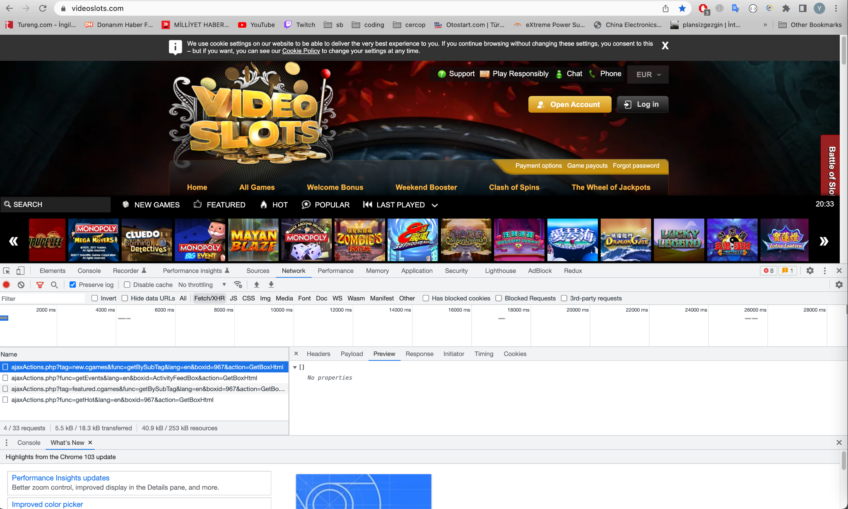

1. Register page popup instead of login, when user pressed play button

1. Prioirity : High (Business decision)  
2. Precondition: go to [www.videoslots.com](http://www.videoslots.com), without login

3. Step to reproduce: on the homepage press play button.   
4. Actual result: Register popup opens instead of login.  
5. Consequences: As usual human habids, many of the websites show their users to login page instead of register page if authentication is needed.  
6. Screenshot